Import Excel File data in to SPI Index Module

Create excel file as follow:

Following perquisite to check before importing,

- Plant Hierarchy and tag naming convention should be defined in your project.
- Tag name in excel sheet should be same as per your project tag naming convention.
- Instrument type & its descriptions should be same as in your project.
- Segregate unit wise tag number & import unit wise.

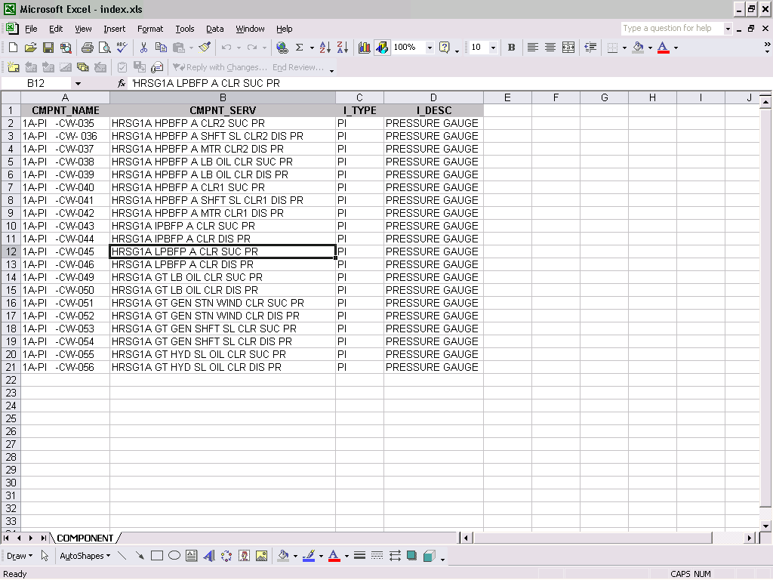
Picture -1
Select data range and define name for data range i.e. Index

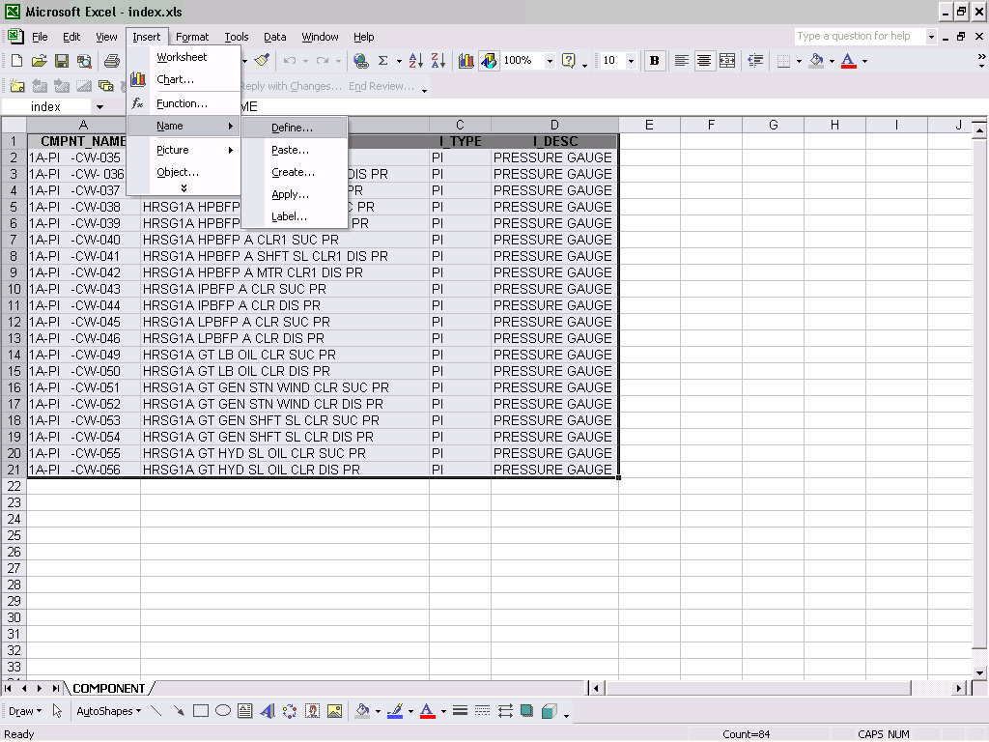
Picture -2
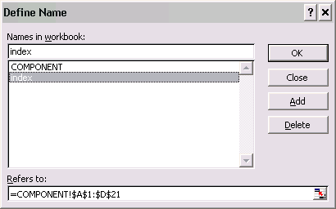
Picture -3
Save this excel file at spi home folder
i.e. E:\spi_2007\index.xls

Now open Import Utility & go to your project domain and select particular unit name.
Right click on “All” create new group:

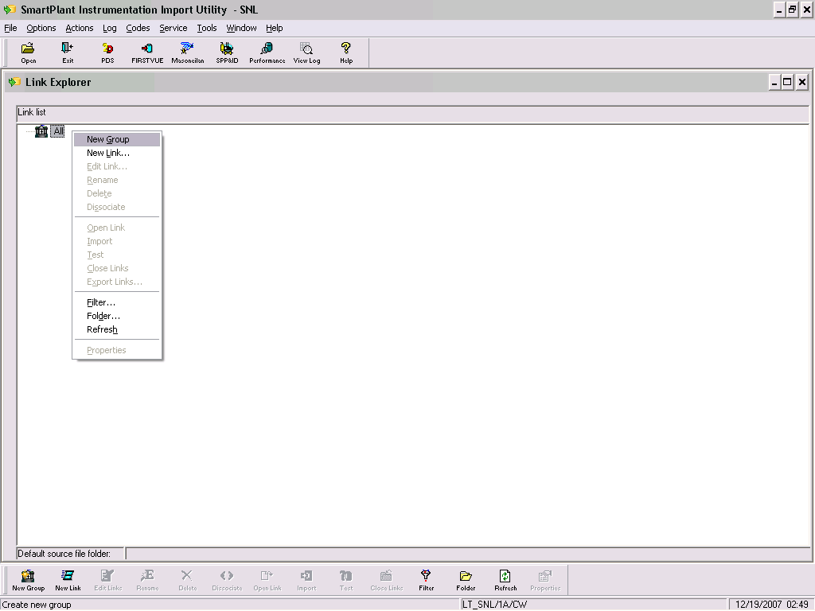
Picture -4
Give group name i.e. Index Data
Right click on this & create new link
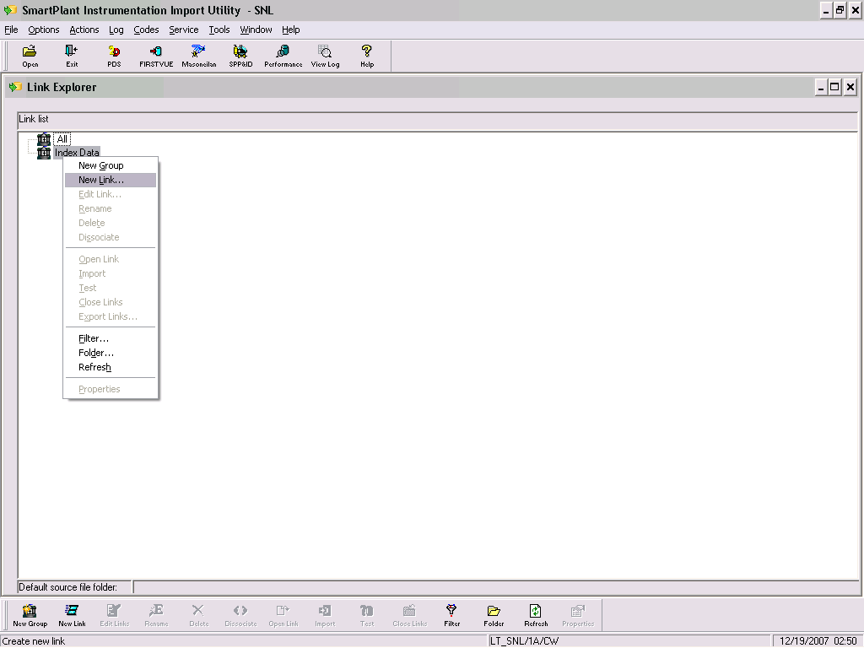
Picture -5

Give link name i.e. Tag
Select Target table Name i.e. COMPONENT
Select Source OBBC Profile as Excel File
Browse the excel file from SPI home folder

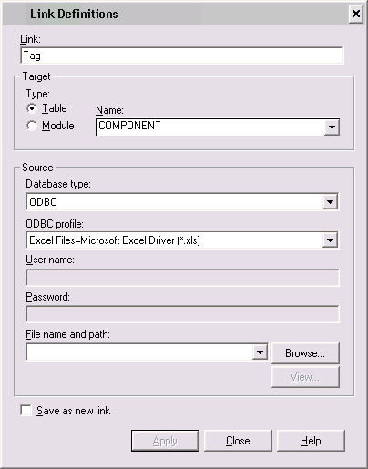
Picture -6

Browse the excel file from SPI home folder

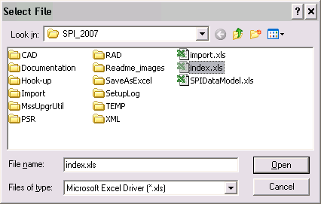
Picture -7

Give Table name as index as given above picture 3

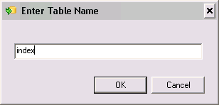
Picture -8

Check view tab to check excel file’s data linkage.
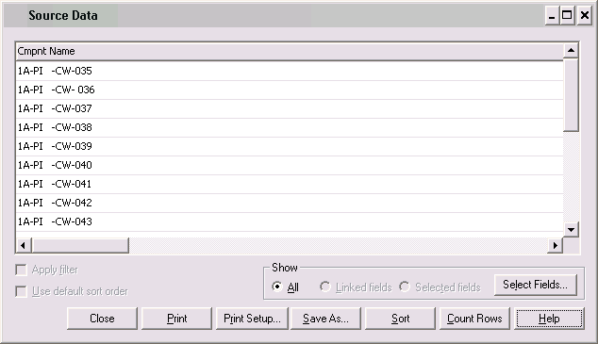
Picture -9
Mark Save as new link and save.

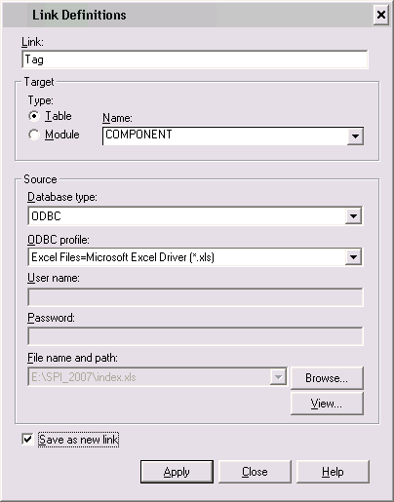
Picture -10
Select Link, right click and go to property

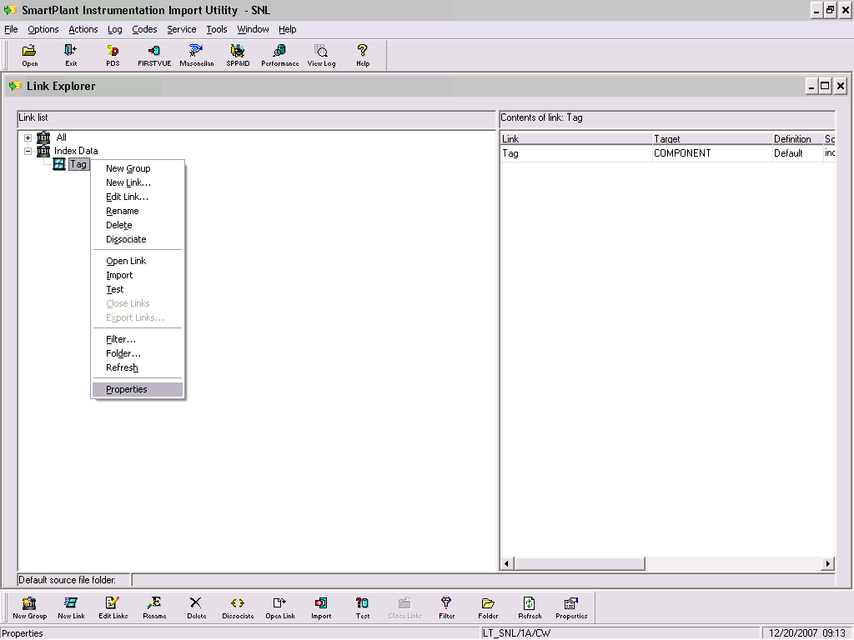
Picture -11
In general Tab select IO type

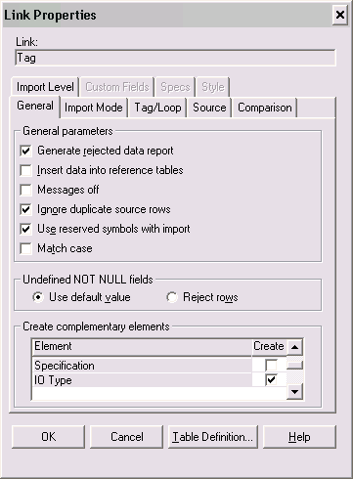
Picture -12

In source Tab select process function assign & go to define

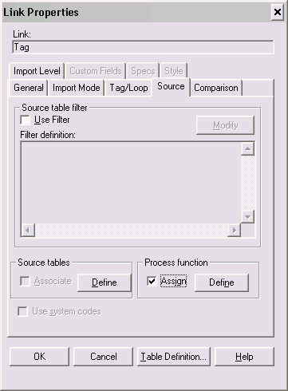
Picture -13

Assign Process Function as pressure by drag & drop as we are importing PI tags & click OK.
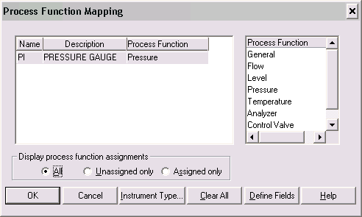
Picture -14

Go to Define Fields & assign Instrument Type & Instrument Type Description and click OK.
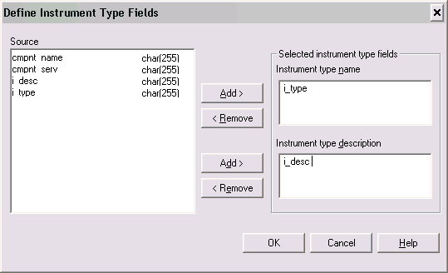
Picture -15

Now go to Instrument Type & give Instrument Type by drag & drop and click OK.

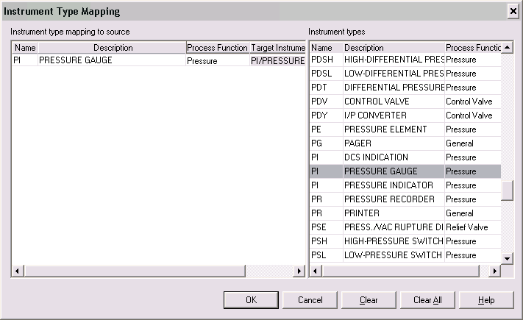
Picture -16
Now go to Tag link, right click & go to Open Link.

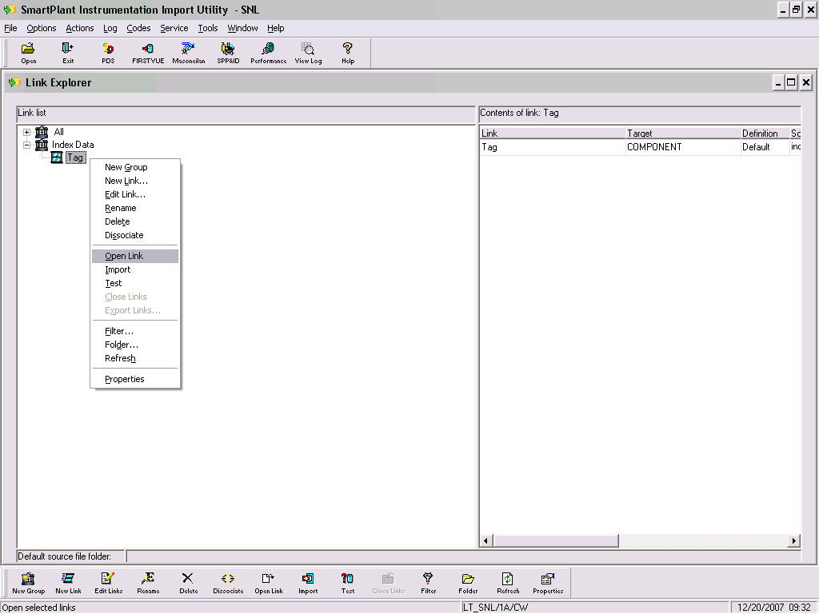
Picture -17

Drag 7 drop i_desc, i_type and cmpnt_serv as below.

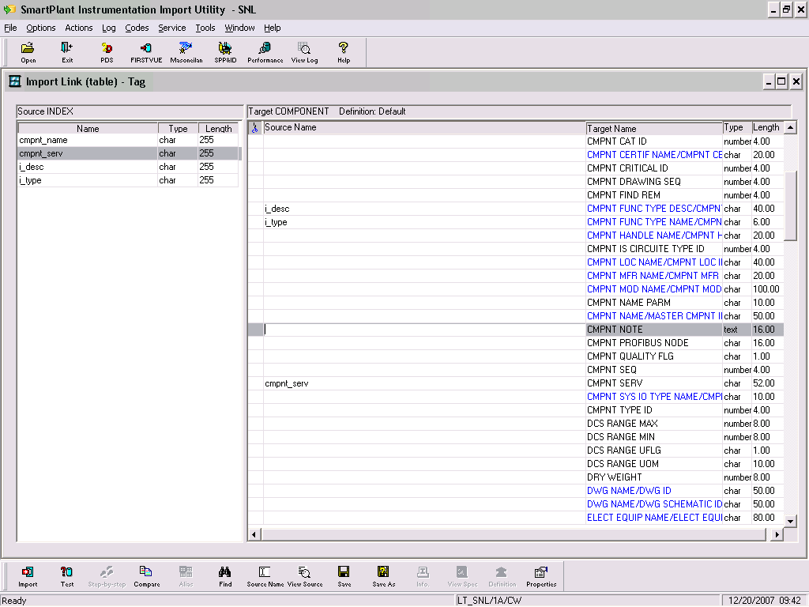
Picture -18

Drag & drop cmpnt_name as below & save this and close this window.

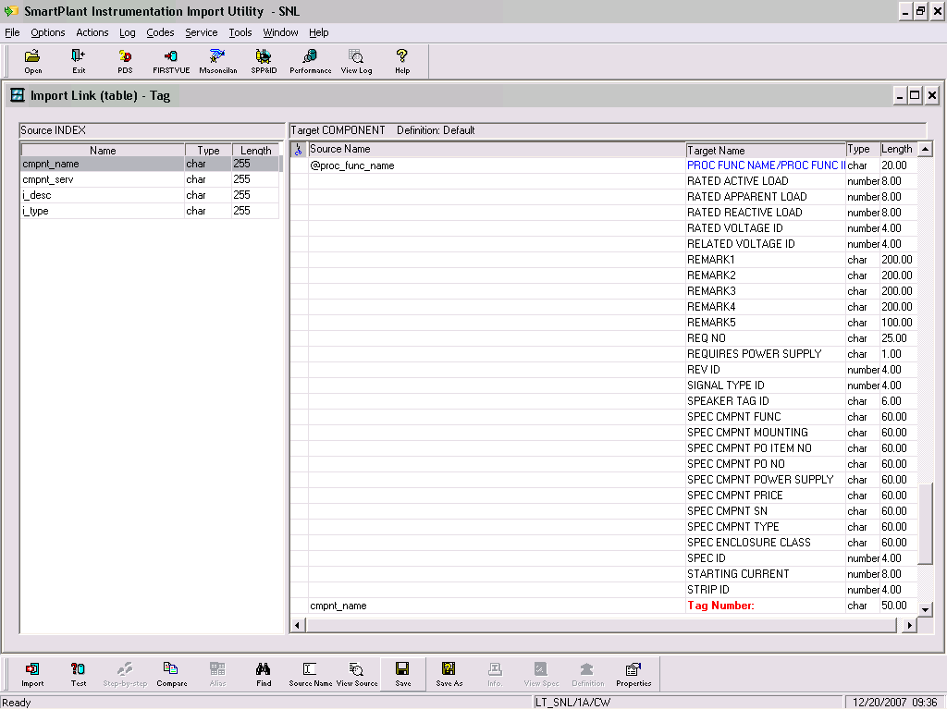
Picture -19

Go to Tag link & click on Test.

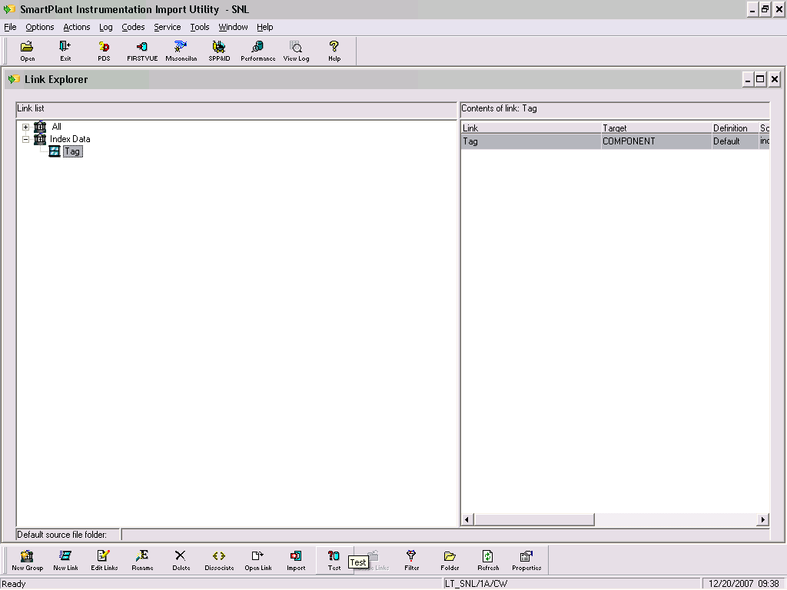
Picture -20

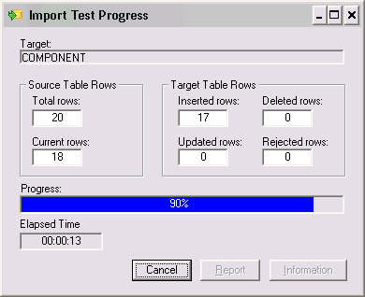
Picture -21

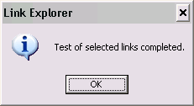
Picture -22

Now go to click on Import.

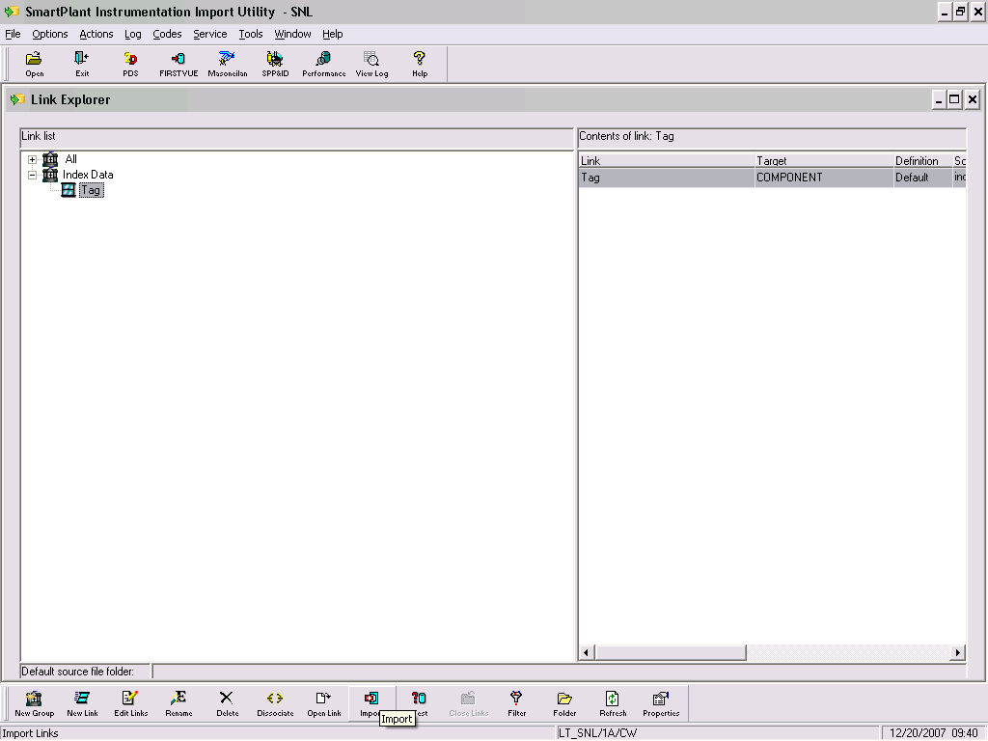
Picture -23

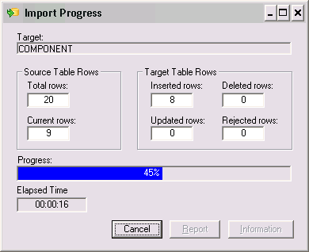
Picture -24

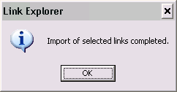
Picture -25

Now Import process completed. You can check view log file. If any error comes then it will be reflected in this log file.

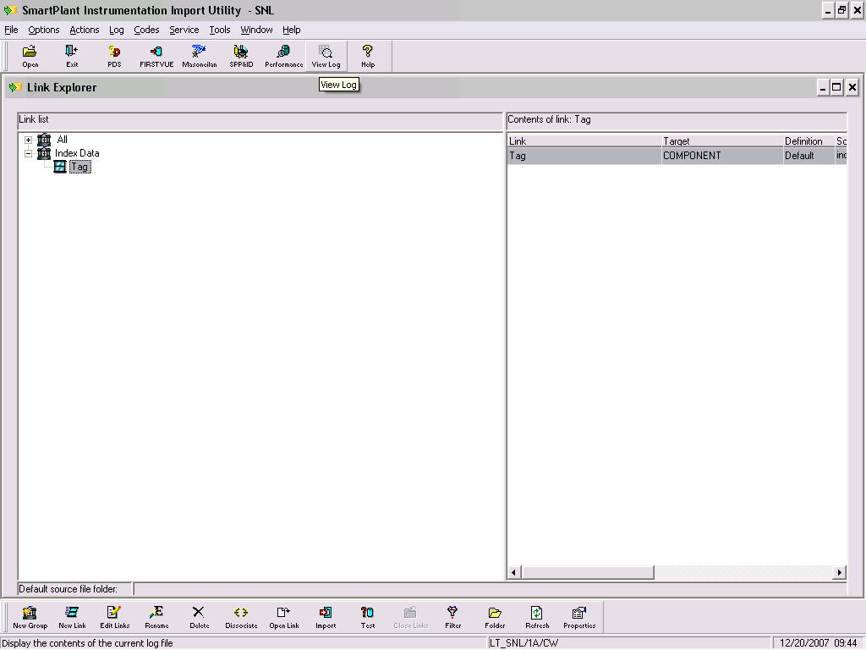
Picture -26

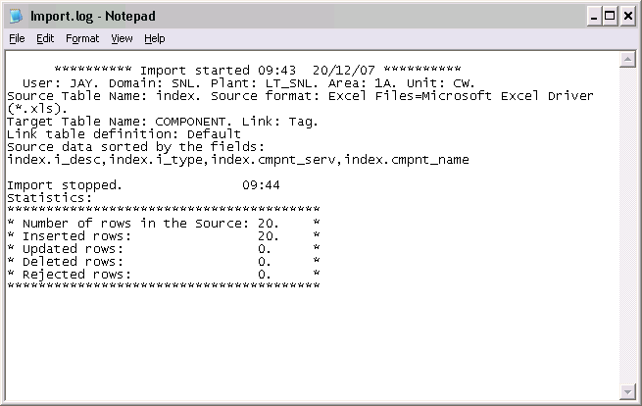
Picture -27

Now you can check all PI tags as in picture 1 are imported in SPI Index Module by opening SPI Index Module.

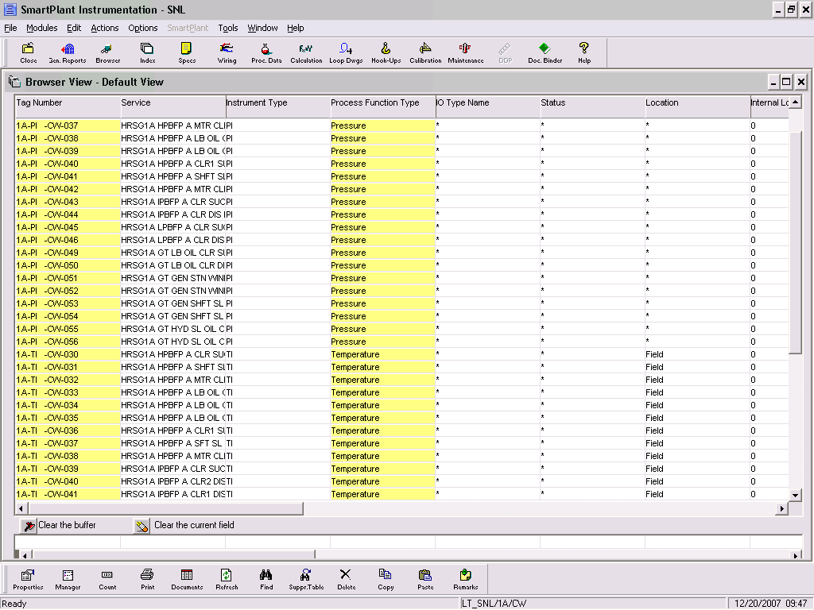
Picture -28

